**UN RAPPORTEURS STATEMENT**

<https://www.ohchr.org/EN/NewsEvents/Pages/DisplayNews.aspx?NewsID=27371&LangID=E>

UK: UN experts voice concern at proposed blanket impunity to address legacy of “the Troubles” in Northern Ireland

GENEVA (10 August 2021) – UN experts* have expressed serious concern about the UK Government's plan to ban all prosecutions, impede investigations, and preclude victims' civil claims in connection with "the Troubles" in Northern Ireland, which would effectively institute a de-facto amnesty and blanket impunity for the grave human rights violations committed during that period.

The proposal, entitled "Addressing the Legacy of Northern Ireland's Past", was announced in a statement by the UK Secretary of State for Northern Ireland before Parliament in July. It would ban all conflict-related prosecutions through the introduction of a statute of limitations to apply equally to all Troubles-related incidents. It would not apply to cases already adjudicated.

Under the proposal, the Police Service and the Police Ombudsman of Northern Ireland would be statutorily barred from investigating Troubles-related incidents, and judicial activity would be ended across the spectrum of criminal cases, and current and future civil cases and inquests. This would effectively also preclude coronial inquests and victims' claims in civil courts.

As noted in the statement, the proposal would bring an immediate end to criminal investigations into Troubles-related offences and remove the prospect of prosecutions.

"We express grave concern that the plan outlined in July's statement forecloses the pursuit of justice and accountability for the serious human rights violations committed during the troubles and thwarts victims' rights to truth and to an effective remedy for the harm suffered, placing the United Kingdom in flagrant violation of its international obligations," the experts said.

In his statement, the Secretary of State justified these measures, stating that criminal justice can impede truth, information recovery and reconciliation. The experts expressed concern that such a justification conflates reconciliation with impunity and noted that criminal justice is an essential pillar of transitional justice processes, alongside truth-seeking and reconciliation.

In this regard, they recalled the importance of adopting a comprehensive approach in a transitional justice process that incorporates the full range of judicial and non-judicial measures. "The essential components of a transitional justice approach - truth, justice, reparation, memorialization and guarantees of non-recurrence - cannot be traded off against one another in a 'pick and choose' exercise," the experts stressed.

The Government's proposal foresees the establishment of a new independent body to enable individuals and family members to seek and receive information about Troubles-related deaths and injuries, and the adoption of an oral history initiative.

In this regard, the experts noted that "the proposed plan does not seem to include measures for establishing the full extent of the truth about the human rights violations perpetrated during the Troubles and about the circumstances, reasons and responsibilities that led to them". "Nor does the proposal seem to ensure that this truth is accessible to all victims and to society as a whole, with due consideration of the needs and safety of victims and with their full consent, as established in international standards," the experts added.

They further noted the insufficient clarification provided regarding the proposed statements of acknowledgement by the various actors of the Troubles and how would this comply with international standards regarding the provision of public apologies, especially with regard to the nature and content of the apology, the responsibilities acknowledged in relation to the violations committed, the author and context of the apology, and the consultation with victims in the design of the apology.

In addition, the experts expressed concern at "the lack of clarity concerning the role that victims will play in the design, implementation and monitoring of the proposed transitional justice institutions and measures, including those relating to memorialization, archiving and truth recovery, and how their full and effective participation will be guaranteed".

The experts urged the British authorities to "refrain from regressing on their international human rights obligations through the establishment of a statute of limitations for conflict related prosecutions and barring all related investigations, inquests and civil claims".

The Troubles in Northern Ireland lasted three decades until the adoption of the Good Friday Agreement in 1998 (also known as the "Belfast Agreement"); and resulted in the death of more than 3,500 individuals and the injury of another 40,000.

The experts have been in contact with the United Kingdom of Great Britain and Northern Ireland concerning this matter.

ENDS

(*) The UN experts: Mr. Fabián Salvioli, Special Rapporteur on the promotion of truth, justice, reparation and guarantees of non-recurrence; Mr. Morris Tidball-Binz, Special Rapporteur on extrajudicial, summary or arbitrary executions.

The Special Rapporteurs are part of what is known as the Special Procedures of the Human Rights Council. Special Procedures, the largest body of independent experts in the UN Human Rights system, is the general name of the Council's independent fact-finding and monitoring mechanisms that address either specific country situations or thematic issues in all parts of the world. Special Procedures experts work on a voluntary basis; they are not UN staff and do not receive a salary for their work. They are independent from any government or organization and serve in their individual capacity.

For more information and press inquiries, please contact Brenda Vukovic (+41 079 444 3940 / bvukovic@ohchr.org )

This article refers: https://www.thedetail.tv/articles/the-cruel-peace-killings-in-northern-ireland-since-the-good-friday-agreement

Dear Brenda Vukovic,

I am convenor of the Malone House Group (MHG), an NGO recognised at the Council of Europe in Strasbourg. We are a group of academics, historians and lawyers based in Belfast which has a different point of view on legacy from that in the Northern Ireland universities and the ‘community’ sector, one which is given most media coverage. This explains why you will probably not have heard mention of us from those groups with whom you are known to be in contact in Northern Ireland.

We read today in the media that, ‘UN experts voice concern at proposed blanket impunity to address legacy of “the Troubles” ’ e.g. in the News Letter -https://app.newsletter.co.uk/full_page_image/page-12-987/content.html

I therefore attach an MHG introduction to inform your experts, Fabián Salvioli, Special Rapporteur on the promotion of truth, justice, reparation and guarantees of non-recurrence, and Morris Tidball-Binz, Special Rapporteur on extrajudicial, summary or arbitrary executions.

We appreciate the direction of travel of the UK Government in its latest proposals and do not regard them as “in flagrant violation of its international obligations”, as your experts assert, nor as “blanket impunity for the grave human rights violations committed during that period”. The reality is that even those opposed to the proposals accept there will be next to no more prosecutions e.g. Jon Boutcher of Kenova.

The proposals do resemble a partial amnesty, something we have experienced in a series of legal decisions over the two decades since the 1998 Good Friday Agreement. It started the process by effectively releasing all the grossest of our human rights violators and paramilitary prisoners.

I am not aware of the UN condemning that particular amnesty and ask, if not why not?

There are indeed contested views of what are international obligations regarding amnesties. They are certainly not subject to uniform condemnation in international law; similarly in relation to Articles 2, 6 and 8 of the European Convention on Human Rights.

What ought to be of greatest concern to the UN is that since our peace process culminated in 1998 there have been 160 Troubles-related political murders, all extrajudicial and not one caused by the army or police. Non-recurrence has therefore a considerable distance to go in Northern Ireland and we would welcome an intervention on that aspect. This article refers: https://www.thedetail.tv/articles/the-cruel-peace-killings-in-northern-ireland-since-the-good-friday-agreement

I recognise this is a complex subject, as you may read from our submissions to the Committee of Ministers at the Council of Europe, so I am not arguing these matters in any detail. We would therefore be happy to discuss the legacy question with Mr Salvioli and Mr Tidball-Binz, either in person or in a virtual meeting if you could pass this message and attachment to them.

Regards

Jeffrey Dudgeon (MHG Convenor)

https://www.ohchr.org/EN/NewsEvents/Pages/DisplayNews.aspx?NewsID=27371&LangID=E

MICHAEL POSNER ARTICLE

<https://www.stern.nyu.edu/faculty/bio/michael-posner>

<https://www.forbes.com/sites/michaelposner/2021/08/04/why-the-uk-government-still-needs-to-acknowledge-its-role-in-northern-irelands-troubles/?sh=3fa71eec3956>

[mhp7@stern.nyu.edu](mailto:mhp7@stern.nyu.edu) **– MHG wrote to him 2 September seeking discussion**

**Why The U.K. Government Still Needs To Acknowledge Its Role In Northern Ireland’s ‘Troubles’**

[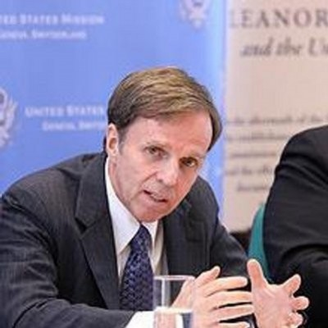](https://www.forbes.com/sites/michaelposner/)

[Michael Posner](https://www.forbes.com/sites/michaelposner/)

Senior Contributor

[Leadership Strategy](https://www.forbes.com/leadership-strategy)

I write about human rights and leadership in a global context.

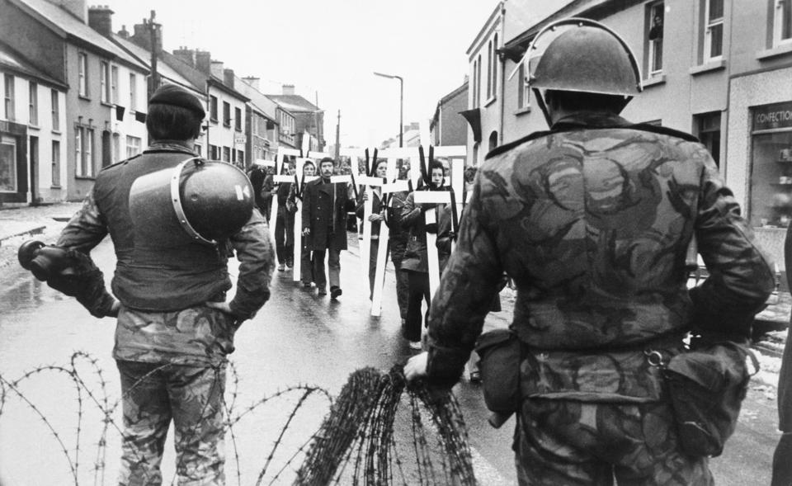

Demonstrators in Dungiven, Northern Ireland, march past British troops on February 6, 1972,

Last month, the British government announced a sweeping and ill-considered [amnesty proposal](https://www.politico.eu/article/uk-seeks-amnesty-to-draw-a-line-under-troubles/) designed to slam the door on any form of legal or public accountability for the political violence that plagued Northern Ireland for three decades. Out of a population of 1.5 million people, more than 3,500, mostly civilians, were killed and more than 40,000 injured during the “Troubles”. The proposed amnesty would foreclose efforts to honestly acknowledge official misconduct during this period, an essential ingredient to building a rights-respecting future.

The “Troubles” began in the late 1960s and continued until the 1998 [Good Friday Agreement](https://education.niassembly.gov.uk/post_16/snapshots_of_devolution/gfa) was signed by the United Kingdom, the Republic of Ireland and the major political parties in Northern Ireland. Northern Ireland, which is still part of the UK, has made notable strides since then, drawing on commitments made through the Good Friday Agreement to reform the police, promote greater equality and power sharing, and reduce political violence. Though political and social divisions are still prominent and unresolved, Northern Ireland is strikingly more peaceful and prosperous than it was two decades ago.

Now on the heels of increasing political instability in Northern Ireland caused by the UK’s withdrawing from the European Union, British Prime Minister Boris Johnson’s government risks further undermining the peace by proposing a sweeping amnesty law which it claims will put past abuses to rest. Almost certainly, the proposed amnesty would have the opposite effect, fueling long-simmering anger from victims and their families and those who are frustrated by the British government’s continued refusal to acknowledge the truth about its past conduct. Experiences from a range of countries in post-conflict situations make clear that those who fail to acknowledge serious human rights violations in their past will not achieve a more stable and democratic future.

The amnesty Johnson is proposing would preclude a sufficient acknowledgement of the British government’s past actions. It would end criminal prosecutions, police investigations, and coroner inquests of all conflict-related offenses, including those carried out by illegal paramilitary groups like the Irish Republican Army (IRA). It also would bar families from seeking civil damages against government authorities, derailing scores of [current court cases](https://apologies-abuses-past.org.uk/about-the-project/). The scope of this proposal is far more extensive than the amnesty law [adopted](https://www.reuters.com/article/us-chile-rights/chile-to-overturn-dictatorship-era-amnesty-law-idUSKBN0H71IN20140912) by General Augusto Pinochet in Chile in the 1970s or other similar laws adopted by other transitional governments. It will seriously undermine the Good Friday Agreement, which was rooted in the British government’s ongoing commitment to respect human rights.

Trying to justify its approach, the British government has [argued](https://apologies-abuses-past.org.uk/about-the-project/) that “any process that focuses on the lengthy pursuit of retributive justice will severely hold back the successful delivery of a way forward.” In a report presented to Parliament in July, British Secretary of State for Northern Ireland Brandon Lewis proposed a vague combination of “information recovery, mediation, and reconciliation” as the best way to provide justice to the families of victims. Lewis asserted that this combination will be more effective than what is “currently achieved through the criminal justice system.”

This analysis is misleading in suggesting that the only option today is criminal prosecution when in fact there are a mix of criminal and civil remedies available. It obfuscates the essential truth that the British government has fiercely resisted offering public acknowledgement of the violations its agents committed during the “Troubles”. To protect its own agents from scrutiny, it is now proposing an amnesty in every case linked to the “Troubles”.

In the 1990s, while at Human Rights First, I [called](https://caj.org.uk/wp-content/uploads/2017/05/JustNews_February2002.pdf) for a full investigation of the [murder of Patrick Finucane,](https://www.humanrightsfirst.org/2007/03/14/Justice-in-Finucane-Case-Long-Overdue) a Belfast lawyer who represented clients accused of political violence. Finucane had been murdered in his home in front of his family in 1989. There is strong evidence that members of the British Army and the Royal Ulster Constabulary were both involved in his murder and that senior British officials participated in a cover-up of this involvement. Yet for 30 years, British officials have gone to great lengths to avoid acknowledging what happened or to take full responsibility for it. The package of remedies Lewis is proposing — information recovery, mediation, and reconciliation — is not designed to provide a truthful accounting of what happened in Finucane’s murder or in scores of other cases in which rights were violated.

The [demand](https://www.dealingwiththepastni.com/) for truth and official acknowledgement should not be seen as an effort to imprison aging former police and military officers for violations they committed decades ago. This will not happen. To prevent future abuses, the British government needs to come to terms with the serious abuses committed by its security forces during the “Troubles”. Pepe Zalaquett, a prominent Chilean human rights lawyer who once led [Chile’s Truth and Reconciliation Commission](https://www.usip.org/publications/1990/05/truth-commission-chile-90), underscored the importance of truth telling when he observed that “acknowledgment is very important in the sense that you say, This is wrong. Now, we admit that we did it, and we shouldn't have done it, it would never happen again, we will take the [corrective] measures.” This is the prescription for what the British government needs to do to address its role in Northern Ireland’s violent past.  The proposed amnesty law is seriously flawed and opposed by every major political party in Northern Ireland and the Irish Government. The Biden Administration and others in the international community who are committed to human rights should strongly urge Boris Johnson to abandon it.

The proposed amnesty would foreclose efforts to honestly acknowledge official misconduct during this period, an essential ingredient to building a rights-respecting future. …Almost certainly, the proposed amnesty would have the opposite effect, fueling long-simmering anger from victims and their families and those who are frustrated by the British government’s continued refusal to acknowledge the truth about its past conduct…It obfuscates the essential truth that the British government has fiercely resisted offering public acknowledgement of the violations its agents committed during the “Troubles”. To protect its own agents from scrutiny, it is now proposing an amnesty in every case linked to the “Troubles”… To prevent future abuses, the British government needs to come to terms with the serious abuses committed by its security forces during the “Troubles”.

Twitter Check out my [website](http://bhr.stern.nyu.edu).

[Michael Posner](https://www.forbes.com/sites/michaelposner/)

I am the Jerome Kohlberg professor of ethics and finance at NYU Stern School of Business and director of the Center for Business and Human Rights. I served in the Obama