*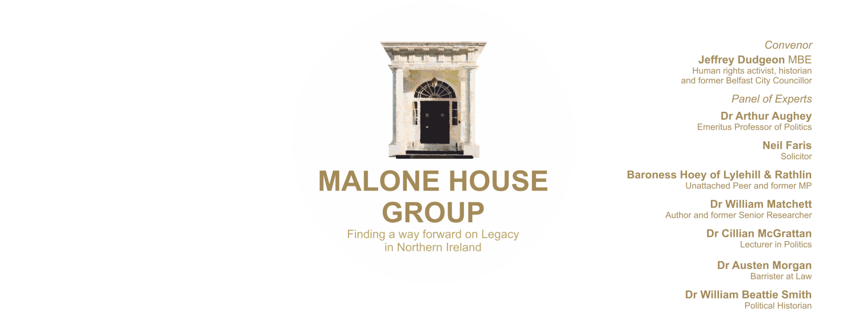****KENOVA INVESTIGATIONS:***

***DRAFT PROTOCOL ON PUBLICATION OF PUBLIC REPORTS***

**23 September 2021**

**MALONE HOUSE GROUP CONSULTATION RESPONSE**

**20 October 2021**

The ‘Kenova Investigations’ comprise the various operations set out in the draft Protocol that is being consulted on. The Protocol concerns the publication of an Interim Report i.e. one before prosecutions conclude.

**1. Background**

Operation Kenova, overall, has four commissions from the PSNI and the Public Prosecution Service (PPS). They arise mostly from the requirement of a Court that, while a police investigation or review into alleged criminality is required, the PSNI, for (disputable) legacy reasons, is not deemed sufficiently independent for the purpose.

They are:

• Kenova (‘An investigation into the alleged activities of the person known as Stakeknife’).

• Mizzenmast (‘An investigation into the death of Jean Smyth-Campbell in 1972'. The McQuillan case at the Supreme Court concerns this death.)

• Turma (‘An investigation into the murder of three RUC officers at Kinnego Embankment in County Armagh in 1982’. They were Paul Hamilton, Allan McCloy and Sean Quinn. Only the criminal aspects are apparently being investigated.)

• Denton (The Barnard/Glenanne Review, ‘An analytical report on collusion in what has become known as the Glenanne Series’).

A fifth such inquiry, named Klina, on the Martin McAuley case and related to Turma, is being conducted by Police Scotland.

The four operations are generally referred to as ‘Kenova’, ongoing now for six years. We understand it has expenditure of some £5 million a year and a staff of around eighty, based in England, to deal with three police investigations and one review. They involve four particular deaths from two events, one police investigation of a more general nature (Stakeknife), and Operation Denton (Barnard/Glenanne in which ‘a review’ has been tasked.

The former Chief Constable of Bedford, Mr Jon Boutcher, is the Officer in Charge of all three operations referred to in the Protocol (and also Operation Denton which is not included in the Protocol). Mr Boutcher’s authority derives largely from requests by the PSNI Chief Constable under section 98 (1) of the Police Act 1996 (the Act). Under the Act, Mr Boutcher has the powers and privileges that a PSNI member has in Northern Ireland as a Constable.

Mr Boutcher has submitted substantial reports comprising 50,000 pages of evidence (the outcome of the Kenova or Stakeknife police investigation) to the PPS. Some 30 Kenova files are now under consideration. Presumably, these relate to possible offences committed by individuals whom Mr Boutcher has identified. It is not known if prosecutions have been recommended in any particular case, as we are not informed of the procedure that Kenova is using. The first decisions on any prosecutions are not expected from the PPS before at least March 2022. *The Irish News* report (below) of a speech at Feile in August 2021 refers.

It remains unclear to us why Operation Denton is not intended to be covered by the proposed Interim Report which may be why no mention of the UVF is made in the list of organisations to be reported on. We would welcome the reason for its non-inclusion and indeed a clear description of where the various Kenova commissions differ.

**2. Interim Report Protocol**

In the website announcement of the proposed Interim Report, Mr Boutcher stated:

“At the very outset of Kenova I made a promise to all the affected families that I would produce a public-facing report outlining our findings to give them the truth of what happened to their loved ones, including who was involved and in what capacity”.

But the announcement, also states that in the draft Protocol he has:

“…laid out his plans for releasing an interim report which will address high level themes and issues concentration on findings of the three key investigations. This report will focus on what was, and was not, happening between organisations: the Provisional IRA and its internal Security Unit, the police, armed forces, intelligence services and their agents and informants. In particular the report will focus on the organisation that committed these awful murders, state intervention or otherwise, and whether steps were, or were not, taken before serious criminal conduct was carried out or subsequent to it to prevent a full investigation”.

We understand this means that it is the intention to proceed with an Interim Report, effectively pre-empting PPS decisions. He however does write, that an Interim Report “will only be possible if PPS and PSNI are satisfied that doing so will not prejudice any ongoing criminal proceedings”.

**3. Prejudice to criminal process and the independence of the PPS**

We would be of the view that PPS and PSNI will and should object to an Interim Report, prior to the conclusion of the PPS’s deliberations. It appears to be inappropriate pressure, certainly on the independent role of the PPS, to come up with the necessary charges that back up any report findings. It could therefore contaminate imminent prosecutions. In relation to the PSNI, we would assume there will be resistance to such an Interim Report on similar and other grounds.

It is indeed of critical importance that the PPS remains entirely independent in making its decisions as to whether or not prosecutions should be mounted. Inevitably, the publication of an Interim Report would be a matter of massive public interest, likely to lead to intense media and political demands that action is taken against the assumed-to-be-guilty parties. That would create unacceptable pressure on the PPS, making it difficult to resist the outcry caused by such publication.

**4. Due process**

Any high level examination of themes and issues will necessarily lead to the identification of those in operational command of the police, army and intelligence services at the time – some of the organisations referred to in the website announcement. This is so, whether or not individuals are specifically named in the Interim Report. This should also draw on aspects of the ECHR other than Article 2, in particular, the often competing Articles 6 and 8 on the right to a fair trial and right to a reputation. However, there is no mention of these articles in the draft Protocol or indeed on the Kenova website.

It would seem therefore near impossible to write an Interim Report on organisations that:

• does not prejudice any later/ongoing prosecutions, given that it will be relatively easy in the Northern Ireland context to infer who in any of the organisations is being scrutinised, and criticised or condemned; and

• avoids material damage to the reputations of those who may be named in, or who can be identified from, the Interim Report

**5. ‘Collusion’**

Given the likelihood of allegations of collusion or the more recent accusation by the Police Ombudsman, Marie Anderson, of “collusive behaviours” by the RUC, we ask, should the Interim Report go ahead (or any later one), that there will, in advance, be a very clear statement of what these terms mean, especially as collusion is not a recognised criminal offence. We therefore request the fairer, more accurate and less tendentious use of the word ‘corruption’ where any criminality is alleged.

**6. The proper limits of police powers and functions**

It is likely that any Interim Report would identify “who was involved and in what capacity” as contained in Mr Boutcher’s promise to families set out in the website announcement. In ordinary circumstances however, a police officer, having submitted files to the PPS, would simply await the outcome – and would not be seeking to issue public reports. That should not be a proper function for police officers in any liberal democracy and is effectively politicising the police.

Furthermore, there is no proper and full due process outlined for any organisation or individual, likely to be subject to Mr Boutcher’s criticism. He is acting as an investigating police officer in seeking out ‘evidence’ but then proposes to act as adjudicator of such evidence. This is the role of the judiciary or a statutory body with the required powers clearly defined.

Any fair procedure would involve several steps and a distinction of roles in the following stages:

1. Investigation and Disclosure of Evidence – to date Mr Boutcher has been carrying out investigations as a police officer and exercising police powers for the purpose. However, he is now proposing in an Interim Report to identify and criticise organisations (and potentially individuals: either specifically or by implication). We understand that this identification and criticism is not for the purpose of mounting prosecutions, but is of the nature of a civil public inquiry into a matter of public concern.

In our view, also, it is impermissible to rely for the purpose of any such report on evidence gathered in police investigations in breach of current procedures.

It is clear that in any civil inquiry those likely to be subjected to criticism in the inquiry's report must be provided in good time, in advance of any interview, with full details of the case that is being mounted against them and must have fair opportunity to make their defence and to challenge the 'evidence'.

1. Adjudication – as already indicated this is not a suitable or proper role for police officers: some independent assessment is required;
2. Draft Report – those to be subjected to criticism must have full opportunity to see all critical parts of the draft Report relevant to them and to make response which the adjudicator must consider before finalising the report.

Personal comments against government policy set out in the recent NIO Command Paper, ‘Addressing the Legacy of Northern Ireland’s Past’, as were made at Feile, seem inappropriate for a police officer whose investigative job necessitates impartiality not simply responding to public opinion. They amount to undue politicisation of the role, as has happened with the Metropolitan Police e.g. Operation Midland.

**7. The consultation process**

The document does not seem to follow best practice in the area of public consultation arrangements. These are available at <https://consultations.nidirect.gov.uk/> and recommend *inter alia* publication (by non-departmental public bodies) on the NI Executive website.

It is worth noting that MHG only became aware of the consultation indirectly. We were not advised in advance or through distribution, as is recommended, despite our longstanding involvement in the issues.

We are also concerned that it does not indicate if all responses could be made public or what effect the FOI Act will have on the process.

**8. Previous representations from the Malone House Group**

On a personal note, having met the Malone House Group in November 2020, Mr Boutcher kindly suggested a further meeting in a number of months. However, despite a request for such a meeting in April and a reminder in August 2021 we did not hear back. We feel this is treatment that other groups would not face and runs contrary to the openness and fairness so often expressed on the Kenova website.

This worrying non-engagement is also true of a legal opinion we submitted on the Independent Review of Article 2 Compliance carried out by Alyson Kilpatrick BL (after reference to it was made in the 2020 meeting). Mr Boutcher indicated willingness to consider any legal questions regarding that review and to pass on what we might submit to Ms Kilpatrick for her comment. Our legal opinion was sent on 9 February 2021 but no further word was heard.

The opinion in question by Peter Smith QC and solicitor Neil Faris was entitled, “The requirement of compliance with Article 2 of the European Convention on Human Rights in legacy investigations in Northern Ireland - Does Operation Kenova comply?’.

In conclusion, and for the several reasons above, we suggest that publication of any report must be deferred until after the conclusion of all related criminal justice processes.

**Jeffrey Dudgeon (Malone House Group Convenor)**

[As this was being written, an email dated 18 October was received from Jon Boutcher suggesting a possible meeting over coffee. It followed him being copied in to recent MHG submissions to the NIO on its legacy proposals, and to the Committee of Ministers of the Council of Europe on Article 2 procedural.]