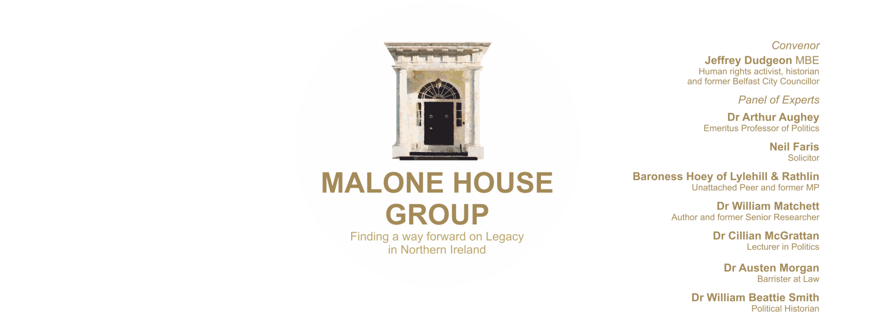

2021

**‘Addressing the Past’ in Northern Ireland**

Dear

I write formally on behalf of the Malone House Group to request a meeting with yourselves to discuss legacy matters. The Group is a non-partisan gathering of professional people with backgrounds in law, government, human rights and political science. We have come together to promote a practicable policy for Northern Ireland on legacy issues. After a conference in 2018 we published, in book form, a collection of papers covering a range of alternative viewpoints (Legacy: What to do about the past in Northern Ireland? Belfast Press). I attach, by way of further information, an introductory statement on our origins which also explains our recent activities and panel of experts.

As part of our work, we studied intensively the Stormont House Agreement of December 2014 (‘SHA’) and the draft Bill which was published by the Northern Ireland Office in May 2018. We have come to the recognition that these proposals could bring neither truth, justice nor reconciliation.

It has long been our view that the Bill would bring few if any benefits and had very serious flaws, not least the inclusion of the non-crime of historic police misconduct and the mixing up of the state’s investigatory and adjudicatory roles, contrary to legal fairness and modern defence rights. I also attach a briefing note which contains a detail of our key legal points and concerns.

We note that you participated, as did we, in the recent deliberations of the House of Commons Northern Ireland Affairs Committee (‘NIAC’) and, as you will know, the Secretary of State published in March 2020 a changed outline of how he would be approaching legacy. We understand that the NIO will be bringing forward developed proposals in the area before the summer.

We have read your submission to NIAC and while there is much on which we would agree, there are points of difference in regard to your approach and support for the SHA and the NIO draft Bill of 2018.

A constructive discussion would we feel be of mutual benefit and particularly that this should take place as soon as may be conveniently arranged for mutual preparation in advance of the publication of any new draft legislation or consultation thereon.

Clearly, in present circumstances, such a meeting would take place by Zoom (or any alternative that you may prefer) and please make contact with me in the hope that this may go ahead.

Yours sincerely

Jeffrey Dudgeon (Convenor)

079 2125 1874 / 028 90664111 [jeffreydudgeon@hotmail.com](mailto:jeffreydudgeon@hotmail.com)