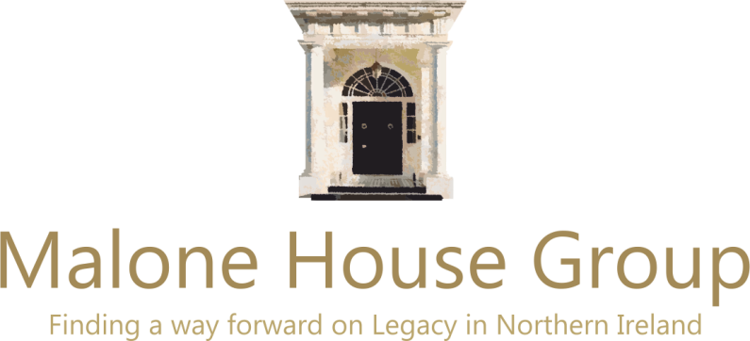

56 Mount Prospect Park

Belfast

BT9 7BG

Tel. 079 2125 1874

[jeffreydudgeon@hotmail.com](mailto:jeffreydudgeon@hotmail.com)

4 September 2020

I am writing to you in your capacity as a member of the Northern Ireland Affairs Committee (NIAC) and in particular about the European Convention on Human Rights.

I convene the Malone House Group of academics, lawyers and politicians in Belfast. We have come into existence as a counterpoint to, in particular, the Queen’s University Belfast legal academics and the nationalist CAJ. They have, to date, controlled the agenda in these areas, a monopoly we are trying to break. Hopefully, the apparent narrowing if not abandoning of some of the NIO’s 2018 draft Bill by the Secretary of State remains the new direction of travel.

We have submitted evidence to the NIAC inquiry and hope to get the chance to be witnesses at a future hearing.

We are also working at present on interventions at the Council of Europe and to its Committee of Ministers who monitor the McKerr group of cases where the UK has been found in breach of the ECHR’s Article 2. Our submission in May was a first from a non-nationalist NGO. We are hoping our legal opinions which are sent by Strasbourg officials back into the Foreign Office (and to the other 46 countries) will gave them new energy resisting the expansionism of that Court where Article 2 is concerned. Our initial submission and that opinion to Strasbourg is enclosed.

I would be pleased to send you links to or copies of the legal opinion accompanying our later submission on the Stormont House Agreement and the NIO’s 2018 draft legacy Bill by Peter Smith QC (who served on the Patten Commission) and solicitor Neil Faris. It concentrates on the proposal to investigate and adjudicate on ‘historic non-criminal police misconduct’, itself contrary to Strasbourg’s Article 6.

We remain of the view that Article 2 as decided by the Supreme Court is not required to have retrospective effect before the year 2000 while spending hundreds of millions of pounds on reinvestigating every Northern Ireland death from 1969 when nothing similar would be funded in England is a pointless exercise. It will bring no truth, no justice and certainly no reconciliation, rather the opposite.

Yours sincerely

Convenor Jeffrey Dudgeon was UUP councillor for the Balmoral DEA in South Belfast until 2019. He is the editor of *Legacy: What to do about the Past in Northern Ireland?*