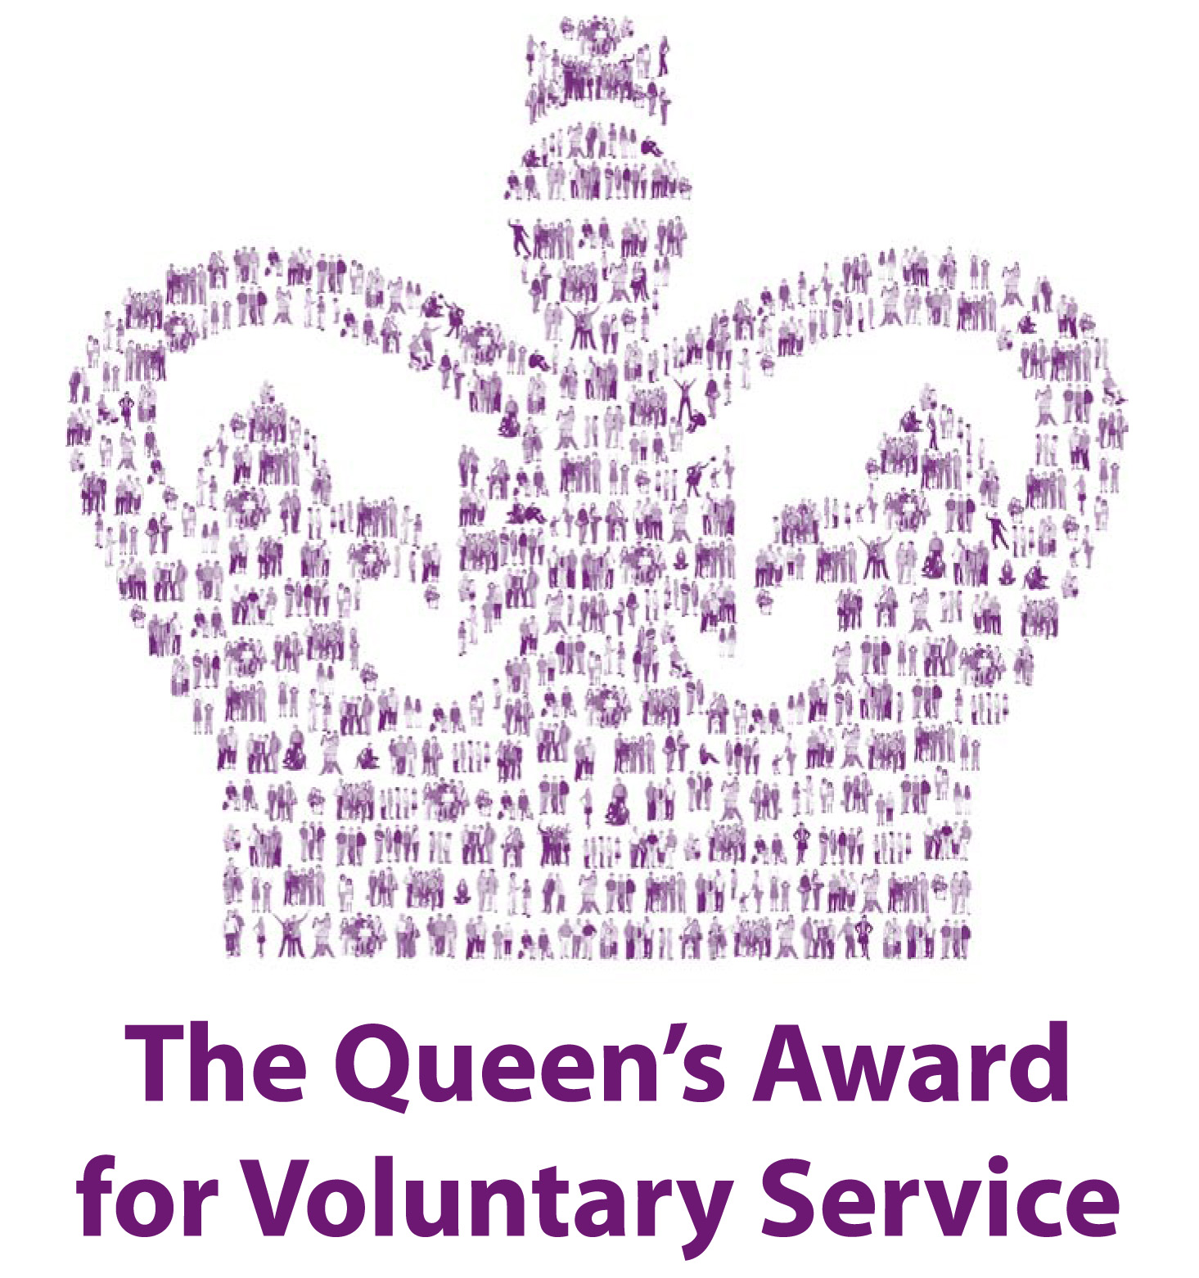
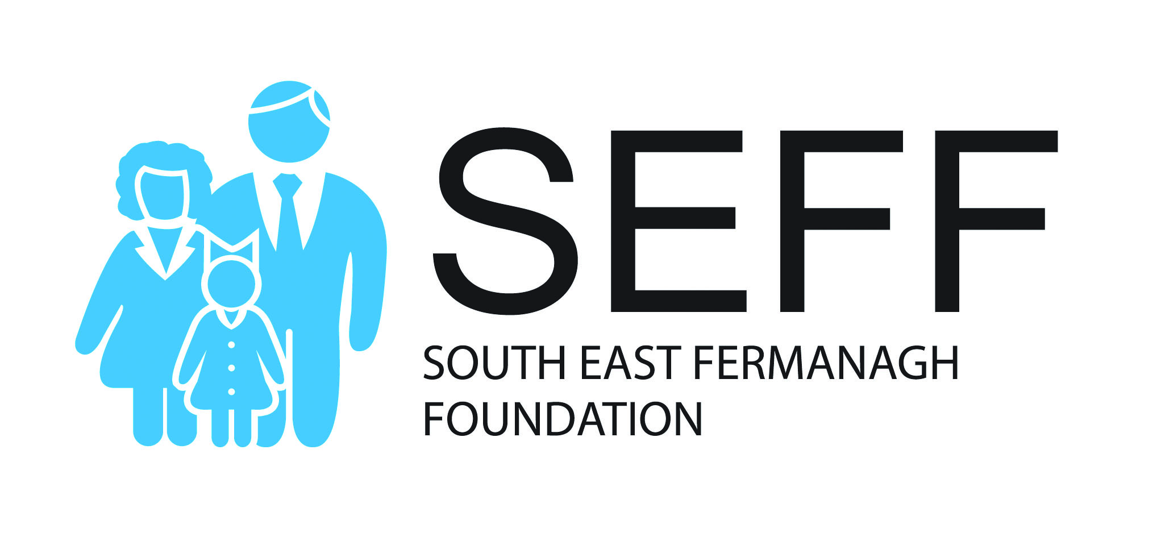
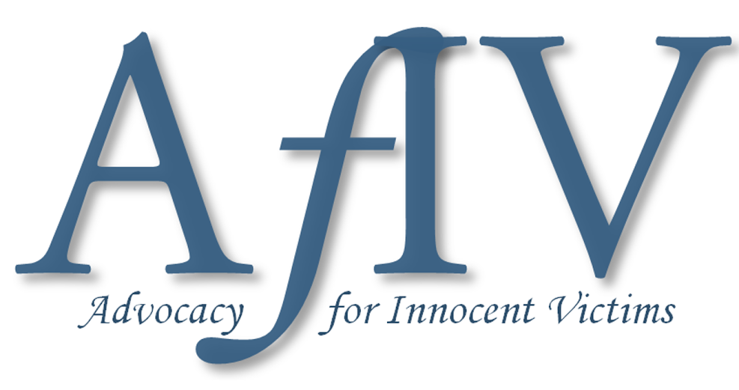

Legacy Consultation led by Northern Ireland Office

SEFF and The wider Innocent Victims United organisation has campaigned for effective legacy structures to be implemented for many years which would respond to the needs of innocent victims/survivors of terrorism and other ‘Troubles related criminal violence.’

IVU is determined that the constituency of victims/survivors whom we serve will be represented over this Consultation period and beyond.

It is essential that you make YOUR VOICE heard at this time!

Date and Venues for SEFF/IVU Consultation of the
Stormont House Agreement (SHA)

- Monday 18th June 2018 - Killyhevlin Hotel, Enniskillen (N.I West)

- Thursday 21st June 2018 - Magherabuoy Hotel, Portrush (N.I North)

- Monday 25th June 2018 - Cohannon Inn, near Dungannon (N.I South)

- Wednesday 27th June 2018 - Decorum N.I, Bangor (N.I East)

- Tuesday 3rd July 2018 - Farmleigh House, Dublin (Republic of Ireland)

- Monday 9th July 2018 - Leeds Town Hall, Albert Room

- Tuesday 10th July 2018 - The Peace Centre, Warrington

- Wednesday 11th July 2018 - Portcullis House (London)
(from 6.30pm - 8.45pm)

(All meetings with exception of London meeting will commence at 7pm,
with refreshments provided from 6.30pm onwards)
What will happen at the Consultation sessions?
A Northern Ireland Office official(s) will be present at a number of the Consultation events and will input for the first hour of proceedings, explaining the proposals, and fielding questions. Reps from the Dept. of Foreign Affairs will also be present at the Farmleigh House, Dublin event.
When the government officials leave, we will then present our views on the proposals. Although there are areas of merit, we also have serious concerns in other aspects and these will be discussed at the meetings. There will be plenty of time to raise questions and concerns during these meetings.
Here is the link to the Consultation documents: https://www.gov.uk/government/consultations/addressing-the-legacy-of-northern-irelands-past
Personnel within SEFF’s Advocacy service team will be on hand to assist individual victims/survivors to submit personalised responses. Post the Consultation events listed above a template response will be devised by our Advocacy team which individuals can then personalise as they would feel appropriate.
If you have any queries at this stage then please contact any member of SEFF’s Advocacy support team directly:
Ken Funston (Service Manager) - 07834488635
Ann Travers (Support Worker) - 07860850003
Wendy Stewart (Support Worker) - 07860850008
Pete Murtagh (Support Worker) - 07860850004
Yasmin Wright (Great Britain Support Worker) - 07860850017
(To assist with planning purposes please contact the SEFF Advocacy Service team on: 028 677 23884 to confirm your attendance at any of the above-named consultation events or contact the Support Worker who you have an existing relationship with)
We continue to impress upon you the importance of engaging in this process, and that you, as an individual, and your group make a comprehensive response before the closing date of 10th September 2018.

