<https://www.belfasttelegraph.co.uk/news/politics/senior-ruc-officers-tell-haass-team-john-larkins-proposals-should-be-implemented-29772293.html>

Raymond White, 21 November 2013 Belfast Telegraph

<https://www.irishtimes.com/news/politics/troubles-amnesty-plan-a-hand-grenade-warn-ex-police-officers-1.4648732>

Raymond White, 16 August 2021 Irish Times

**Troubles amnesty plan a ‘hand grenade’, warn ex-police officers**

**Former members would not accept being classed as ‘combatants’ alongside paramilitaries**

Mon, Aug 16, 2021, 21 Updated

Brian Hutton

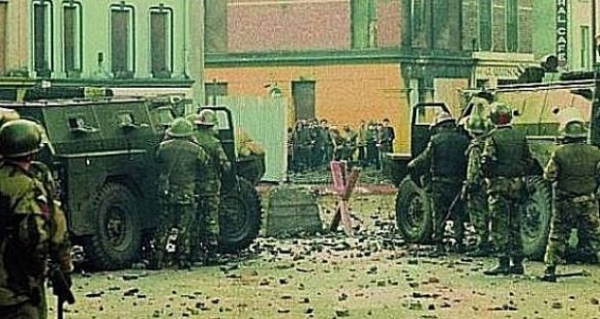

People confront British soldiers on William Street in Derry minutes before paratroopers opened fire, killing 14 civilians on what became known as Bloody Sunday.

A Troubles amnesty is a “hand grenade” that has united all sides in the North against plans to ban prosecutions from conflict-related killings and other crimes, retired police officers have said.

[Raymond White](https://www.irishtimes.com/topics/topics-7.1213540?article=true&tag_person=Raymond+White), a former assistant chief constable of the Royal [Ulster](https://www.irishtimes.com/topics/topics-7.1213540?article=true&tag_organisation=Ulster) Constabulary (RUC) and ex-head of its Special Branch, said retired members of the police would not accept being classed as “combatants” alongside paramilitaries under the British proposals.

“We invested our lives in upholding the law, and thought that anyone who acted in an unlawful manner, when due process was applied, would have the charges against them heard before the courts,” he said.

“If found guilty, they should be sanctioned in the normal way, and that includes police officers as well.”

Last month, Britain’s northern secretary [Brandon Lewis](https://www.irishtimes.com/topics/topics-7.1213540?article=true&tag_person=Brandon+Lewis) told Westminster that legislation could be enacted by the autumn which would end the possibility of future prosecutions for Troubles-era killings and other crimes committed before 1998.

UK prime minister [Boris Johnson](https://www.irishtimes.com/topics/topics-7.1213540?article=true&tag_person=Boris+Johnson) said the proposals would “draw a line under the Troubles” and acknowledged they were partly prompted by British political and public opposition to the prosecution of former British soldiers.

Stormont’s political parties and the Government in Dublin are all opposed to the plans.

Mr White, who leads a legacy committee on the [Northern Ireland Retired Police Officers Association](https://www.irishtimes.com/topics/topics-7.1213540?article=true&tag_organisation=Northern+Ireland+Retired+Police+Officers+Association) (NIRPOA), said the proposed amnesty would “afford a veneer of legitimacy to out and out terrorists” by including them with military and police.

“We do not accept being combatants, we were police officers,” he said.

“Ninety per cent or more of our daily time was spent administering a police service in relation to burglaries, break-ins, stolen vehicles, domestic disputes and road accidents.

“That’s what we were engaged in during the Troubles by and large. We had to deal with terrorist activity where it arose but we were in that position as the legitimate police service, and we are not prepared to be put in a position of being combatants needing an amnesty.”

Mr White said the courts are the “right and proper place for anyone with criminal behaviour to appear”.

**Evidence for a prosecution**

The retired police chief admitted there were “bad apples” in the RUC and that “there is no doubt about it” that they should be pursued where there was enough evidence for a prosecution.

“We prosecuted some in courts where we had sufficient evidence to do so and we dismissed and got rid of the others, if we didn’t have that threshold of evidence to go through the courts,” he said.

“That’s not to say there are not one or two out there who sold their souls to the paramilitaries, out of fear or whatever else.”

It is a “human right” that if someone is wronged that they have access to the courts, he said.

However, he warned that it remains “extremely difficult” to prosecute historic cases and that “harsh realities have to be faced up to” in what can be achieved.

NIRPOA is proposing an independent international panel decide what Troubles-related cases should be reinvestigated based on the possibility of prosecutions because the “task is too big for any homegrown solution”.

A “clearing house” could decide which cases need to be reopened for police inquiry or passed to the Police Ombudsman or “other specialist investigative bodies” or whether there should just be “information giving or release” to families, Mr White said.

Of the outstanding Troubles-related killings, almost half occurred in the 1970s and a “very low” number could be resolved now, because at the time crime scenes could often not be established, he said.