**NEWS: Legacy debate panel announced**

By [admin](https://unionistvoice.com/author/admin/) on September 3, 2018

Unionist Voice Policy Studies in partnership with the Families Research Policy Unit will host a legacy consultation and panel discussion this Wednesday evening (5th September) at 7pm at the Con Club, Newtownards Road, east Belfast.

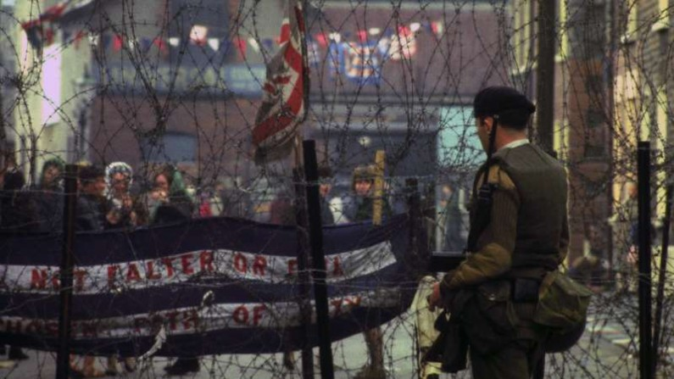

The evening will provide an opportunity for all those in attendance to familiarise themselves with the proposed legacy structures and also to engage in an interactive panel discussion.

\***The DUP were invited to attend, but due to attempts by their CEO Timothy Johnson to dictate the parameters of debate and which media would be permitted to be present, they will no longer be participating.**

There will be a 10 minutes victims presentation by FRPU at the beginning, followed by the discussion. The panel will consist of the following guests;

**Independent Chair Allison Morris**

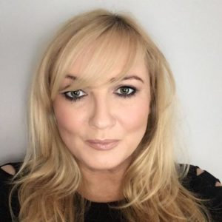

Allison is a multi-award winning journalist and the current security correspondent for the Irish News based in Belfast. She has won multiple awards for her work in a career spanning over 20 years and is a regular political commentator on BBC, UTV, RTE and other mainstream platforms. Allison also has a monthly slot on Sky News’ daily newspaper review and writes a weekly award-winning column for the Irish News.

**Rev Mervyn Gibson**

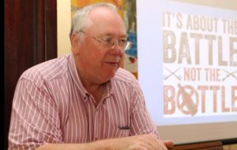

Mervyn is a local east Belfast minister and is the Grand Secretary of the Orange Order. He is a retired RUC officer and a former chair of the loyalist commission. He regularly contributes to the mainstream media on a range of issues and was part of the DUP’s negotiating team during the Haass talks. He has spoken out strongly against an Irish Language Act and is passionate about ensuring any legacy structures are fair, balanced and proportionate.

Top of Form

Bottom of Form

**Doug Beattie MC MLA**

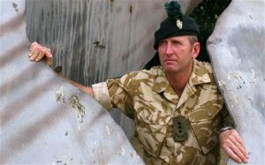

Doug joined the British Army in 1982, rising to the rank of Regimental Sergeant Major during over 28 years of service. During that time he served in Bosnia, Kosovo, Iraq and Northern Ireland being awarded the General Officer NI commendation, the Queens Commendation for Bravery and the NATO Meritorious Service Medal. He was commissioned from the ranks in 2005 gaining promotion to captain. He was awarded the Military Cross for his exploits in Afghanistan and upon leaving the British Army he wrote the bestselling book ‘An Ordinary Solider’. He is a current MLA and the UUP’s spokesperson on Legacy.

**Jamie Bryson**

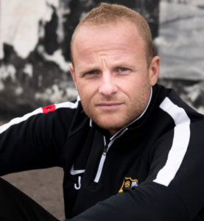

Jamie is the editor of Unionist Voice. He writes for Brexit Central and is a contributor on a range of mainstream media platforms including BBC, Sky News, RTE and other outlets. He was previously a weekly columnist for Belfast Live. Jamie is the author of the banned Nama book ‘The Three Headed Dog’ and has written a number of pamphlets arguing against mandatory coalition Government and the Belfast Agreement. In 2018 he appeared before the Northern Ireland Affairs Committee at Westminster to give evidence to their ‘Devolution and Democracy’ inquiry.

**Cllr Jeffrey Dudgeon**

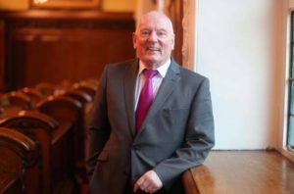

Jeffrey is a current UUP Cllr and Chairman of the Malone House legacy group which encompasses solicitors, veterans, political activists, journalists and academics. He is best known for bringing a landmark legal case to the European Court of Human Rights which led to the decriminalisation of homosexuality in the United Kingdom. Jeffrey was part of the UUP negotiating team during the Haass talks. He was awarded an MBE by Her Majesty the Queen in 2012.

The organisers have asked all those in attendance to ensure their contributions to the debate are respectful and wish to make clear that everyone is welcome to the debate to express their views in a fair and constructive manner.

<https://hansard.parliament.uk/lords/2018-09-05/debates/DA7C2984-EF6B-45D8-A766-AC14BD60631F/NorthernIrelandLegacyOfTheTroubles>